Day28 in-class

Jessica Choe

Question1

#Question1================================================================

setwd("C:/Users/user/Desktop/2020spring/504 data visualization/In-class assignment")

library(ggplot2)

load("Jan2020Flight.Rdata")

#Select necessary variables only and start using "delay2".

delay2<-delay %>% select(ORIGIN_STATE_NM,OP_UNIQUE_CARRIER,dep_hour,dep_min)

#Calculate total number of flights per carrier.

delay_sum<- delay2 %>%

group_by(OP_UNIQUE_CARRIER)%>%

summarise(num_flights=n())

#Create bargraph.

ggplot(data=delay_sum) +

geom_bar(aes(x=OP_UNIQUE_CARRIER,y=num_flights),

stat="identity",fill="lightblue") +

labs(x="Carrier", y="Number of Flights",

title="Number of Flights Per Carrier")+

coord_flip()+theme_bw()

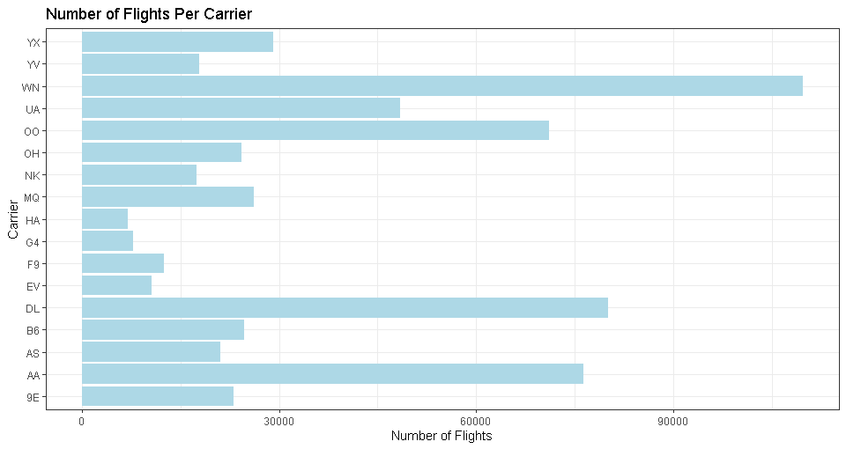

Question 2

#Question 2========================================================

#Create a new variable for the departure time.

delay_dptime<-delay2 %>%

mutate(dp_time=dep_hour+dep_min/60) %>% group_by(ORIGIN_STATE_NM)

#Reorder the state by the amount of the median. (decreasing order)

reordered_State <- with(delay_dptime, reorder(ORIGIN_STATE_NM,dp_time, median , na.rm=T))

#Boxplot

ggplot(delay_dptime)+

geom_boxplot(aes(x=reordered_State, y=dp_time),fill="skyblue")+

coord_flip()+

labs(y="Departure time",x="State",

title="Boxplots for Departure Time for Each State")+

theme(axis.text.y = element_text(size=8,angle=45),

axis.text.x = element_text(size=8,angle=45))+

theme_bw()

#For some reason, changing the size of the axis using axis.text.y does not #work in R mark down although it works in R

